**Team:😐**

1. **Mohamed abdalgafar Badawy**
2. **Omar Ayman**
3. **Ali Taha**
4. **Ahmad shreef**
5. **Mohamed mosad**

**The Documentation of Hotel Management System**

**In this documentation we are going to talk about the Hotel Management System, first we will talk about E.R.D.**

**The E.R.D is a diagram in which the programmer use, to know how the system will be and how he handles the project and make the map that the system will depends on it.**

**In this E.R.D there is 3 entities, and each entity consists of some attributes and each entity relates to some relationships and primary and foreign keys and all of them are connected.**

**So, the E.R.D is the base that the programmer builds on.**

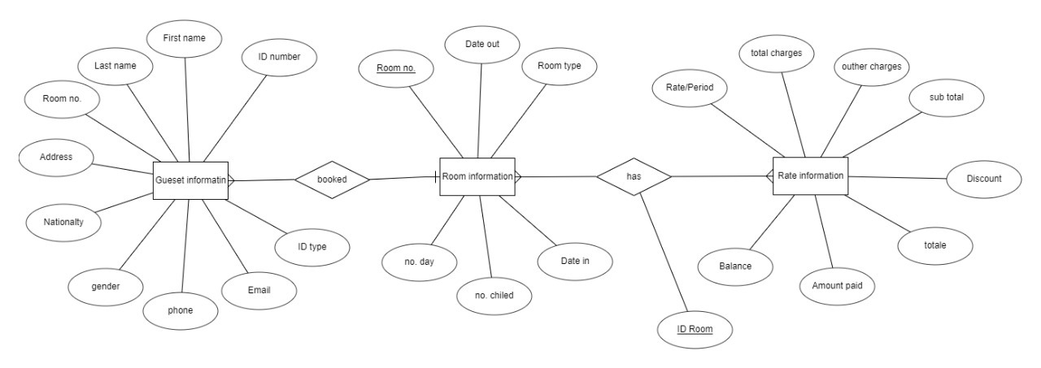

Figure 1 Diagram of E.R.D

**Then we are going to talk about the second most important component among these components which is Mapping.**

**The mapping is a set of tables that clarify the E.R.D and it is easier to the user to read it.**

**And if you look in figure 1 front you will see that the 3 tables are connected to each other by foreign keys and primary keys and in the figure 1 front the foreign key in 1st table pointing to primary key in the second table and the foreign key in the 2nd is pointing to the foreign key in the third table the mapping is also a way to make the database in easier way.**

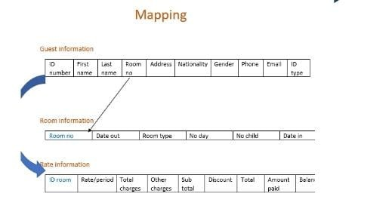

Figure 2 Database Mapping

**After that it comes the login G.U.I that consider a gate to the main G.U.I so in the login G.U.I the user just complete the login details like Write his username and his password to login to the main project and after filling them just click on the button LOGIN to go to next G.U.I but if he wants to cancel the operation, he just need to click on The Cancel button like the figure 3 front.**

**Just I want you to know that if he login as an admin he will get full access like the figure 6 at the bottom, but if he login as a user he has just a limit access that the admin gives him like the user can’t Delete any thing from the database, he will not the Delete button like the figure 5 at the bottom.**

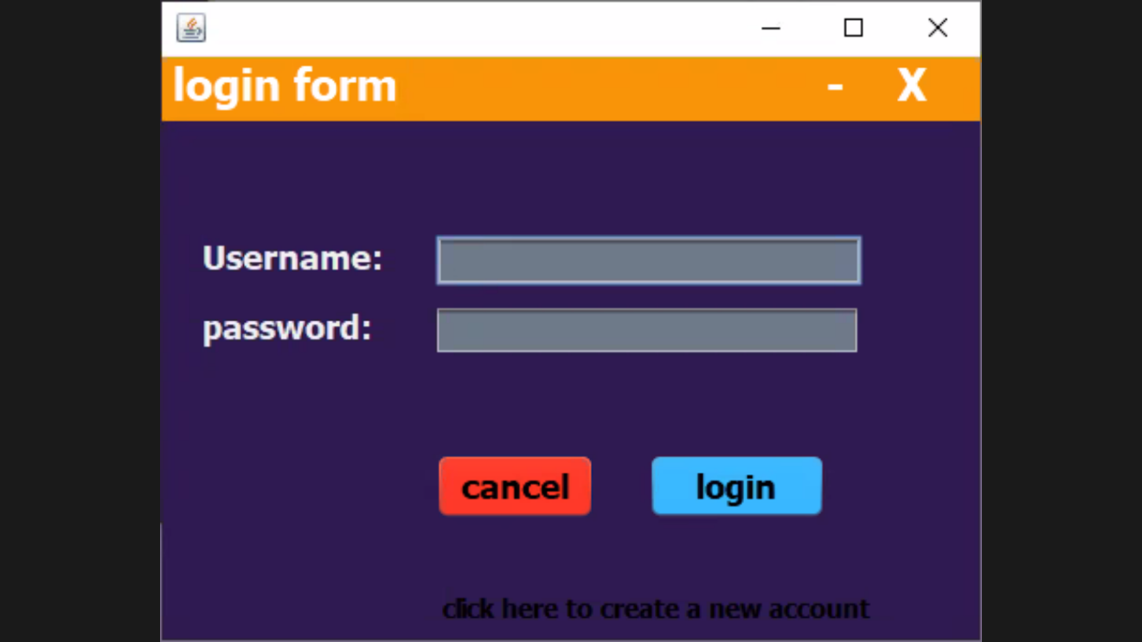

Figure 3 Login Form

**After that it comes the second G.U.I and that G.U.I let the user Know how much rooms that the hotel has and know how much rooms are empty and if the one of room is empty the user can access it and click on the room’s number button and fill up the information that I asked for and if he wants to back to the previous page, he just need to click on BACK button like in figure 4 front.**

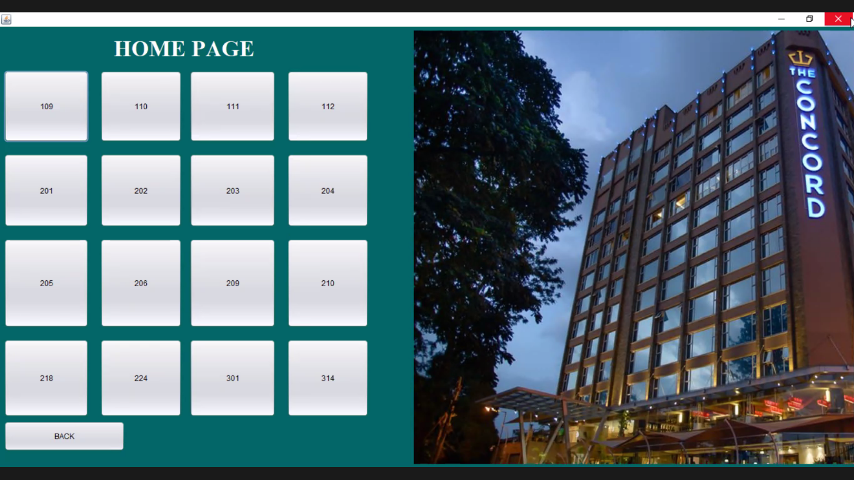

Figure 4 HOME PAGE

**After that it comes the main G.U.I and the base of the project which is the Hotel Management System.**

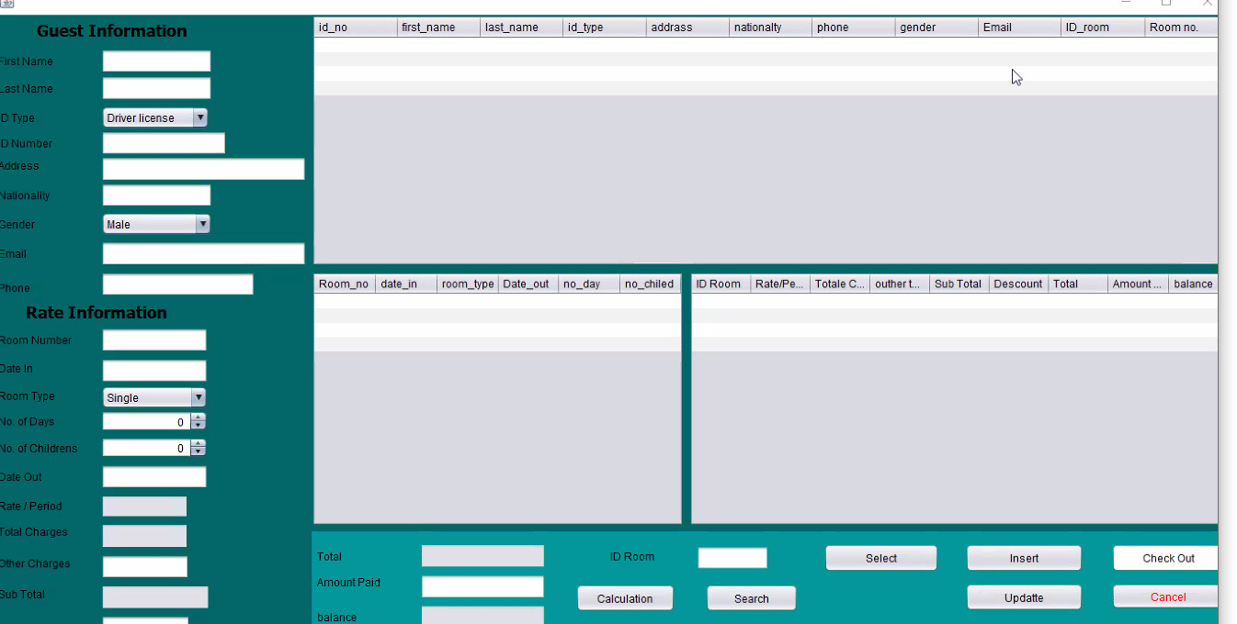

Figure 5 The Main G.U.I if he login as a user

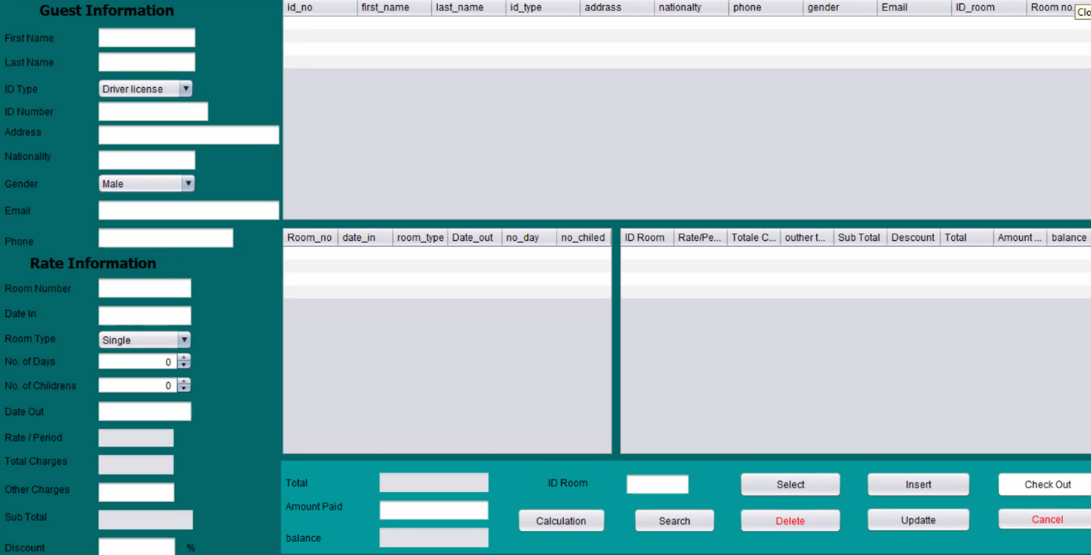

Figure 6 The Main G.U.I if he login as an admin

**In this page after the admin or user click LOGIN button this G.U.I will be shown as the user need to fill this information to be saved in the database as important information and as shown in the figure above if the user or the admin needs to add a customer in this hotel, he just needs to fill the information and give him a Room’s number and click on Insert button and if he wants to calculation the total of the price just need to click on Calculation button and if he wants to search of the one of customers he just needs to fill up the ID Room and click on Search and if he wants to update the information of the one of customers just need to fill up the new information and click on Update button and if the customer needs to pay just needs to click on the information of the this customer and click on Check Out button and the information will be automatically Update and if he wants to delete the information of the one of customers just need to select the information and click on Delete button and if he wants to show the all the data in database just need to click on Select button and the finally if he wants to cancel the all operation just need to click on Cancel button and the System will shutdown and get out from the project.**